February 2022
From the Director
Greetings!

Less than two weeks until the sweetest day of the year and any excuse to eat chocolate works for me!

Although February is a short month, the Library has a wealth of events for you!
Celebrate Dental Health month by checking out the new Story Walk selection, Sugarbug Doug, sponsored by Colmar Dentistry for Kids. Join us for Story Time at the Library every Tuesday at 10 am and every Thursday at 4 pm, as well as at the Montgomery Township Recreation Center on February 9 and 23 at 10 am. Book clubs are meeting in a hybrid format – in person and through Zoom. Please join us!

Below are the details for a special Lit & Wit Zoom event to meet Sadeqa Johnson, author of the award winning book, Yellow Wife. Each month the Red Cross has a Blood Drive at the Library and we encourage you to make your appointment online to donate on Thursday, February 17, 1-6 pm.

Happy Reading & Happy Valentine's Day,

Jayne Blackledge, Director
ABOUT US
North Wales Area Library
233 S. Swartley St.
North Wales, PA 19454
215-699-5410
Hours
Monday thru Thursday: 11 am to 7 pm
Friday: 11 am to 4 pm
Saturday: 10 am - 5 pm
Sunday: Closed
Catalog
Donate
Programs
Email Us
Calendar
Digital Resources
LIT & WIT - A VIRTUAL CHAT WITH AUTHOR SADEQA JOHNSON
Tuesday, March 22 @ 7 pm
Join us at the Library or in the comfort of your own home for a virtual chat with the author of one of O Magazine’s Most Anticipated Novels of 2021, The Yellow Wife, Sadeqa Johnson.
Signed copy of the book and treat bag are included for this virtual event!

Get more information or purchase tickets here.

A BROADWAY BLACK HISTORY CELEBRATION - SAVE THE DATE

Monday, February 28 @ 7 pm
Join us for a celebration and discussion of African tribes and traditions with Broadway performers.

Check the library website for program updates.

BOOK CLUBS
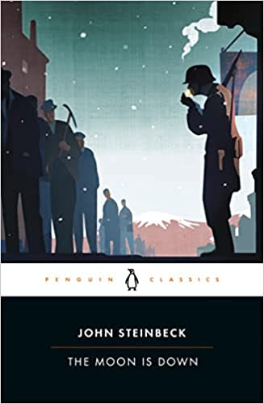
Tuesday, February 15 @ 7 pm
The Moon is Down by John Steinbeck

Wednesday, February 23 @ 2 pm
The Beekeeper of Aleppo by Christy Lefteri

STORY TIME

Join Miss Vicki for Story Time @ the Library on Tuesdays at 10 am. Stories, songs and family fun. For ages 3 to 5 and their caregivers.

Miss Elaine will lead a story time @ the Library on Thursdays at 4 pm. For ages 3 to 5 and their caregivers.

Story Time will be held at the Montgomery Township Community & Recreation Center on Wednesdays, February 9 & 23 @ 10 am.

BEGINNER'S YOGA

DUNGEONS & DRAGONS
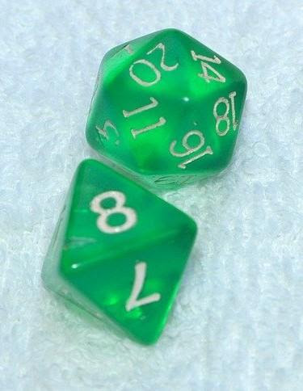
Saturday, February 19 @ 2 to 4 pm
Ages 12 to 16
Join us for our Dungeons & Dragons Club at the Library. Read through parts 1-3 of the basic rules in the Player's Handbook. Bring a pencil, notebook, D&D dice set (if you have one), a copy of any 5th edition sourcebooks you'll be using (if you have them), and your character sheet. Email Adah to register.
BOARD GAME MEET-UP
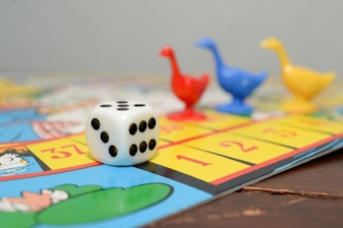
Saturday, February 19 @ 12 pm
All Ages
This group meets on the third Saturday of the month. Fun for all ages. No registration required. For more information, email us.
KNITTING & CROCHET @ YOUR LIBRARY

Monday, February 14 @ 1 pm
Anyone who wants to share ideas and enjoy crafting together is invited to join our Knitting & Crochet Club. No sign up necessary. This club meets on the second Monday of the month at 1 pm. For more information, contact Barbara.

NEW - Individual one hour knitting & crochet lessons are available for a $10 donation to the Library. Please call the Library at 215-699-5410 to schedule.
RED CROSS BLOOD DRIVE

Thursday, February 17 @ 1 to 6 pm
Register here.
ACCESSIBILITY IMPROVEMENTS TO LIBBY'S DIGITAL PLATFORM
Overdrive recently announced accessibility improvements to its app Libby for reading ebooks, listening to digital audiobooks and streaming video.

